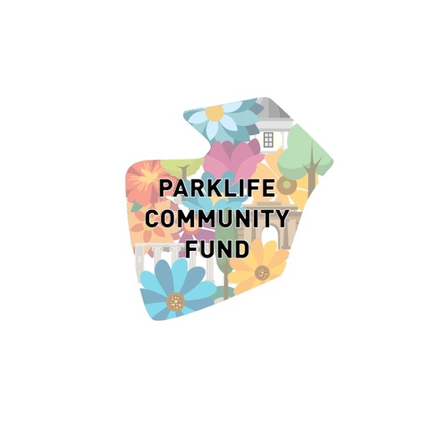

PARKLIFE COMMUNITY FUND 2023
Micro-grants Programme Application Form

Practical Details

1.Group Name, Contact Name, Address, Telephone Number and Email address

2.Bank details (name of bank, name of account / group, sort code and account number)

3. Are you known (i.e. have received funding) to / from the relevant local authority to where your group is based in the last 3 years? Please delete as appropriate Yes/No (if no have you applied for funding but were unsuccessful?)
4. Conditions of the grant (in addition to it being used as outlined in the proposal) are
a) That the Parklife Community Fund logo is used by groups who receive funding: this will be sent to successful applicants
b) In addition to funds, groups will also receive support and input (and are expected to attend wherever possible) the Parklife Community Fund network which meets twice a year
Your proposal (please answer in 500 words or less)
On the next page, please tell us about: your group’s background and experience / what you do, what you propose to do with this funding, why you think it is important, how much money you are asking for and how you will spend it.
Please return this form to communityfund@parklife.uk.com by Sunday 21 January 2024. Maximum microgrant award is £600

